|  |  |  |
| --- | --- | --- |
|  | | |
| Name: | | |
| Assessment Task | | |
| ATAR Physics Unit 4 | | |
| **Task 7: Determining Planck’s Constant** | | |
|  | | |
| Task Details | | |
| Science Inquiry Investigation | | |
| Weighting: 6% | | |
| Time Allowed: 1 ½ class lessons | | |
| Content Description | | |
| * on the atomic level, electromagnetic radiation is emitted or absorbed in discrete packets called photons. The energy of a photon is proportional to its frequency. The constant of proportionality, Planck’s constant, can be determined experimentally using the photoelectric effect and the threshold voltage of coloured LEDs * *This includes applying the relationships* * c = λ f , E = h f = ,   Ek = h f - W | | |
| **Task Preparation** | | |
| Blackbody radiation, photoelectric effect, and Atomic spectra | | |
| **Assessment Task** | | |
| Test conditions:   * Data collection: group work * Final answers should be given up to three significant figures and include appropriate units where appropriate. Questions containing the instruction "ESTIMATE" should be given two significant figures and include appropriate units where applicable. * Scientific Calculators are allowed. * No notes allowed. * Formula sheet is provided. | | |
| Standard test items | | |
| **Submission** | | |
| * Part 1 – table and Part 2= processing and analysis * Data Sheet | | |
| **Achievement** | | |
| _________/29  __________% | Teacher Signature |  |

TASK 6 Year 12 Science Inquiry: Plancks Constant

**Planck's Constant Investigation and Planck's Constant with in-class validation task (6%)**

**Description:**

* This activity is used to determine the value for Planck’s Constant by using a device which utilises LED’s.
* The task is broken in to two (2) sections. The first is used to derive the data and may be completed in groups. The second is used to analyse the data and activity itself.

-------------------------------------------------------------------------------------------------------------------------------------

**Section 1: Data Acquisition**

The device used for this activity is shown below: TOTAL: ____ / 29 Marks

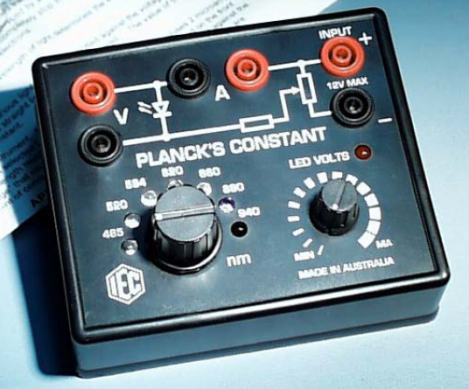

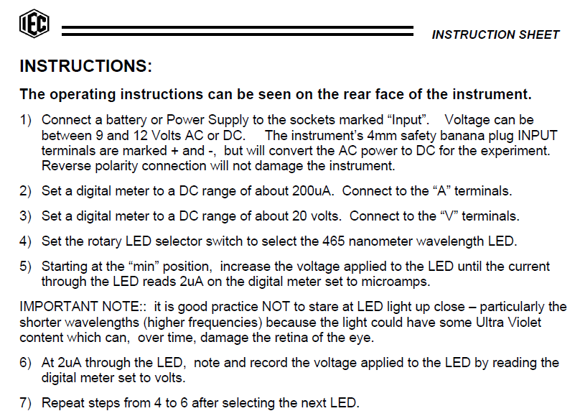

**Data from Section 1** – Use this page to record your data which is to be used for Section 2.

(4 marks)

**NAME: ______________________________________________________________________**

**Section 2: Data and activity analysis**

Answer the following questions in the spaces provided.

1. Use your data to create a table showing the applied voltage against the frequency of the LED. Show one calculation below.

(2 marks)

1. Use your data from Q1 (page 4) to draw a graph. (4 marks)
2. An LED is a two terminal semiconductor light source. In the unbiased condition a potential barrier is developed across the p-n junction of the LED. When we connect the LED to an external voltage in the forward biased direction, the height of potential barrier across the p-n junction is reduced. At a particular voltage the height of potential barrier becomes very low and the LED starts glowing, i.e., in the forward biased condition electrons crossing the junction are excited, and when they return to their normal state, energy is emitted. This particular voltage is called the **knee voltage** or the **threshold voltage**. Once the knee voltage is reached, the current may increase but the voltage does not change. (sourced from http://vlab.amrita.edu)

The amount of energy attained by the photons is proportional to the voltage.

E = V q

This energy is also proportional to the frequency shown by the equation:

E = h f

* 1. Determine the slope of the graph in Q2. (2 marks)
  2. Use the equation above to show how the slope can be used to determine Planck’s Constant.

(3 marks)

1. Identify 2 random errors in the activity and how to rectify them. (2 marks)
   1. ___________________________________________________________________

___________________________________________________________________

* 1. ___________________________________________________________________

___________________________________________________________________

1. Identify 2 systematic errors in the activity and how to rectify them. (2 marks)
   1. ___________________________________________________________________

___________________________________________________________________

* 1. ___________________________________________________________________

___________________________________________________________________

1. Another experiment was performed at MIT where an apparatus was used to measure the retarding voltage as per the diagram below (Source: http://web.mit.edu/lululiu/Public/pixx/not-pixx/photoelectric.pdf)

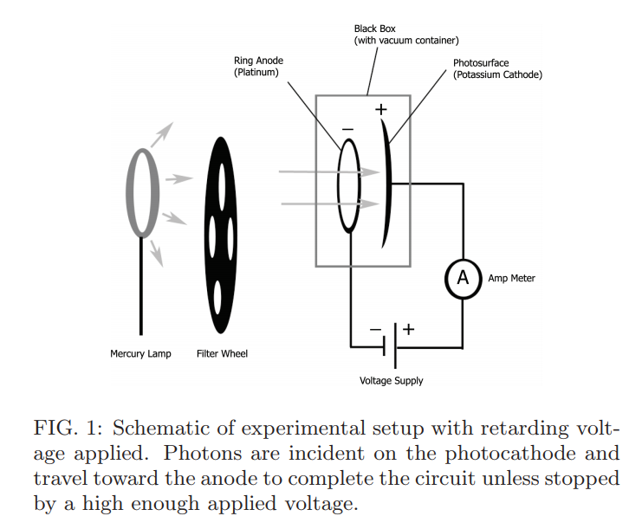

An Oriel mercury lamp use was used at the same time as a filter to produce 4 wavelengths as per the table below:

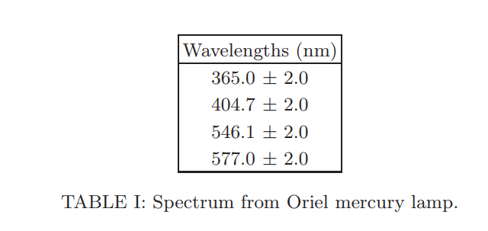

* 1. With reference to the photoelectric effect, what type of spectrum is produced by the lamp?

(1 mark)

__________________________________________________



6.2 What does the term mean? (1 mark)

________________________________________________________________________

________________________________________________________________________

6.3 The retarding voltage is used in conjunction with the ammeter. When the current stops at a certain voltage, this is called the retarding voltage. Explain how the retarding voltage can be used for a certain wavelength to determine Planck’s Constant. (2 marks)

6.4 Why is the experiment conducted in a black box and has a vacuum? (2 marks)

________________________________________________________________________

________________________________________________________________________

________________________________________________________________________

________________________________________________________________________

6.5 Examine the table below and complete the “Error” column: (1 mark)

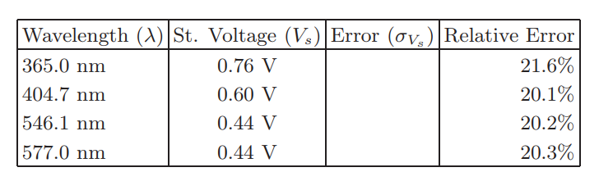

6.6 At the conclusion of the report, the following statement was made:

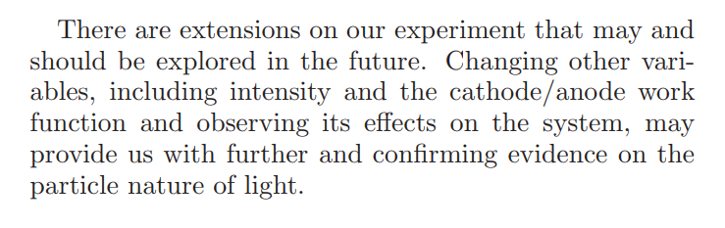

6.6.1 Why would addressing the “intensity” be a possibility for future experiments?

(1 mark)

________________________________________________________________________

6.6.2 What is “work function” and why would researching effects be beneficially for future experiments? (2 marks)

_________________________________________________________________________

­­­_________________________________________________________________________

SPARE GRAPH



Spare paper

END OF TEST